EXPERIMENT NO.3

Procedure:-

Step 1:- visit amazon web services webpage.

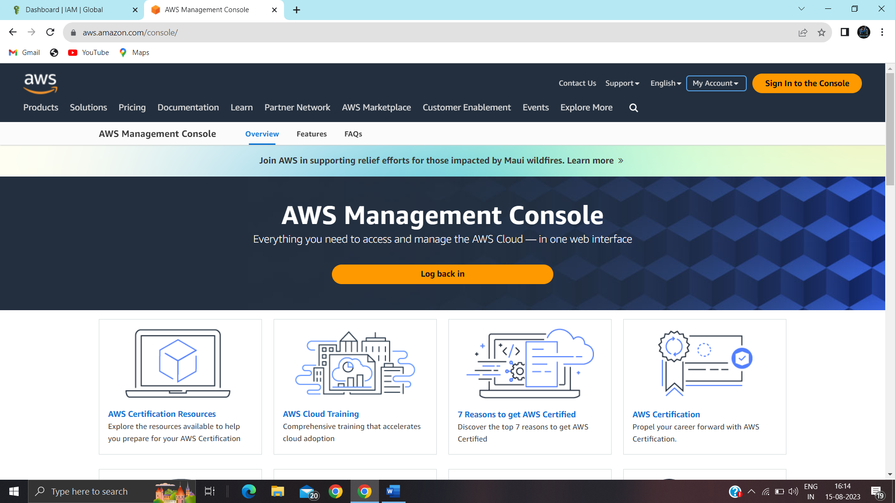

Step 2:- sign in using root user, enter your email address and click on next.

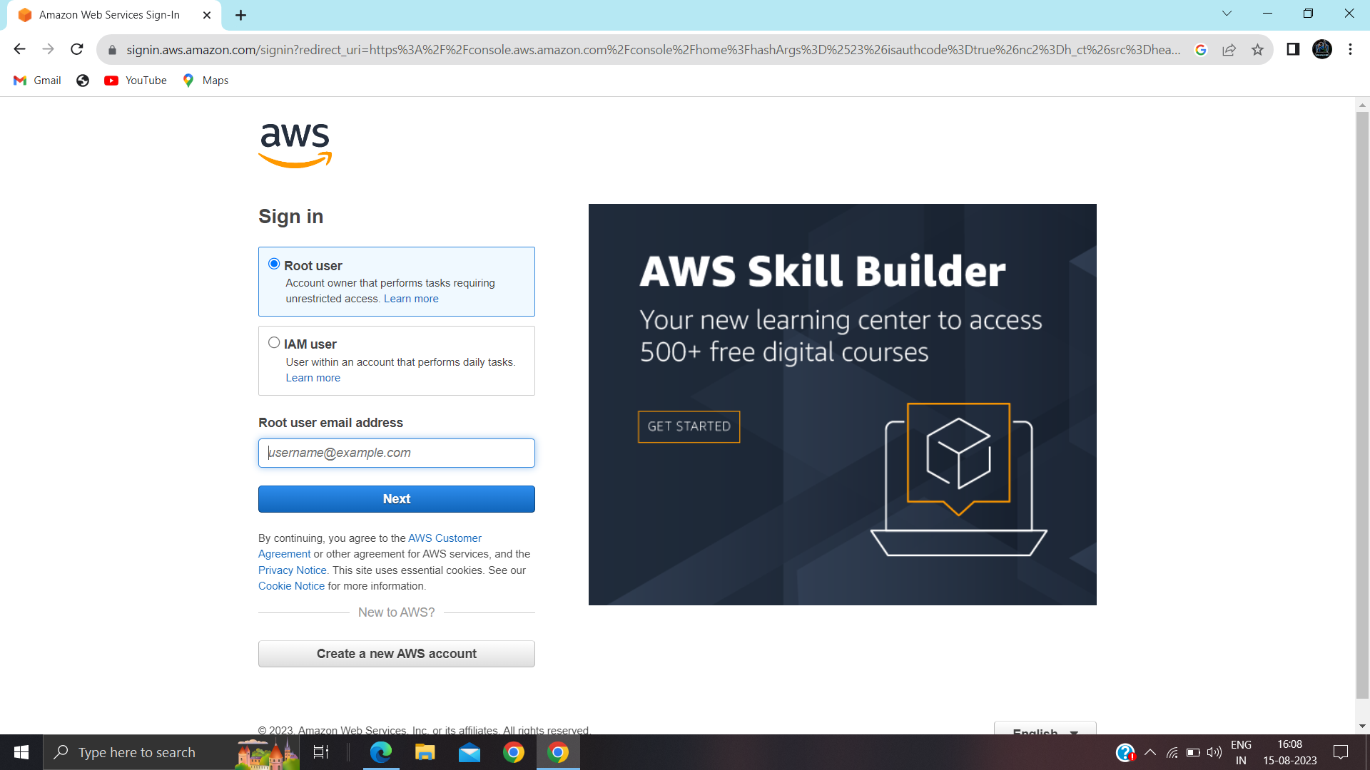

Step 3:- It will take you to this home page, go to services.

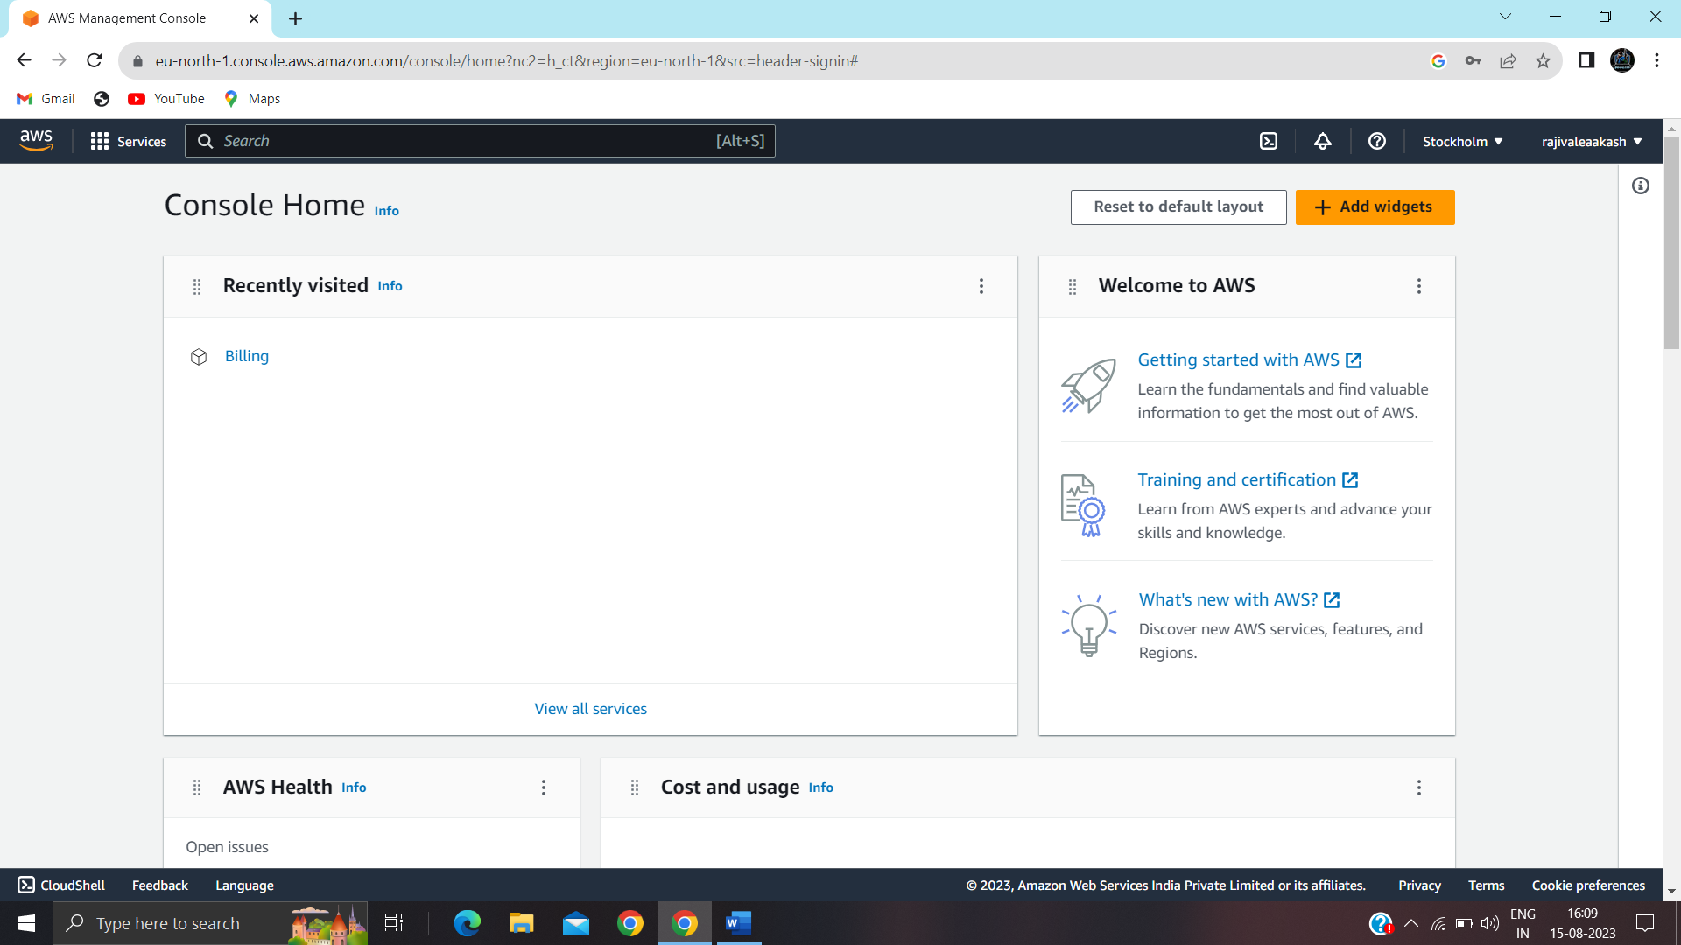

Step 4:- select cloud9.

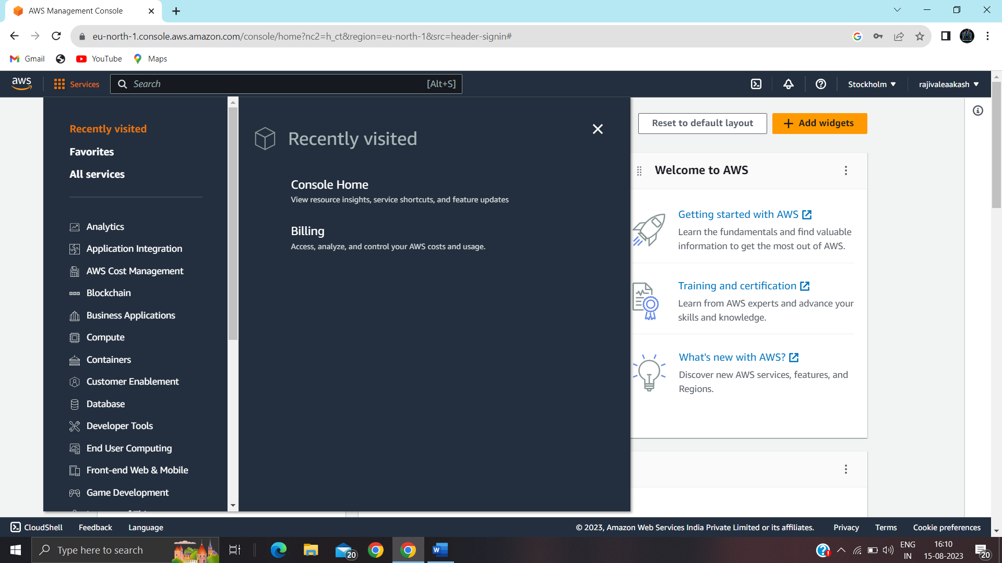

Step 5:- select create environment.

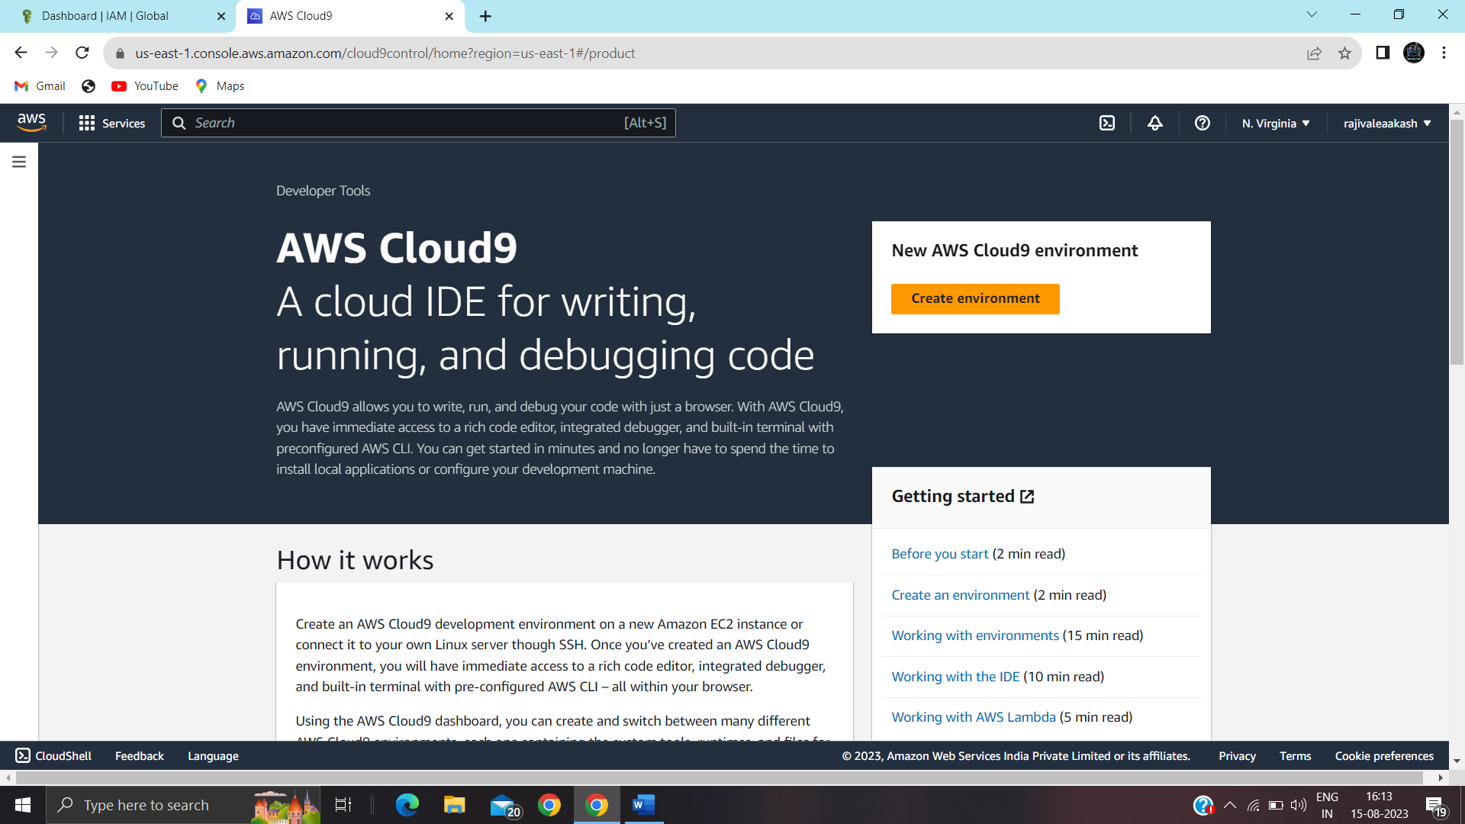

Step 6:- fill in the details, select environment type.

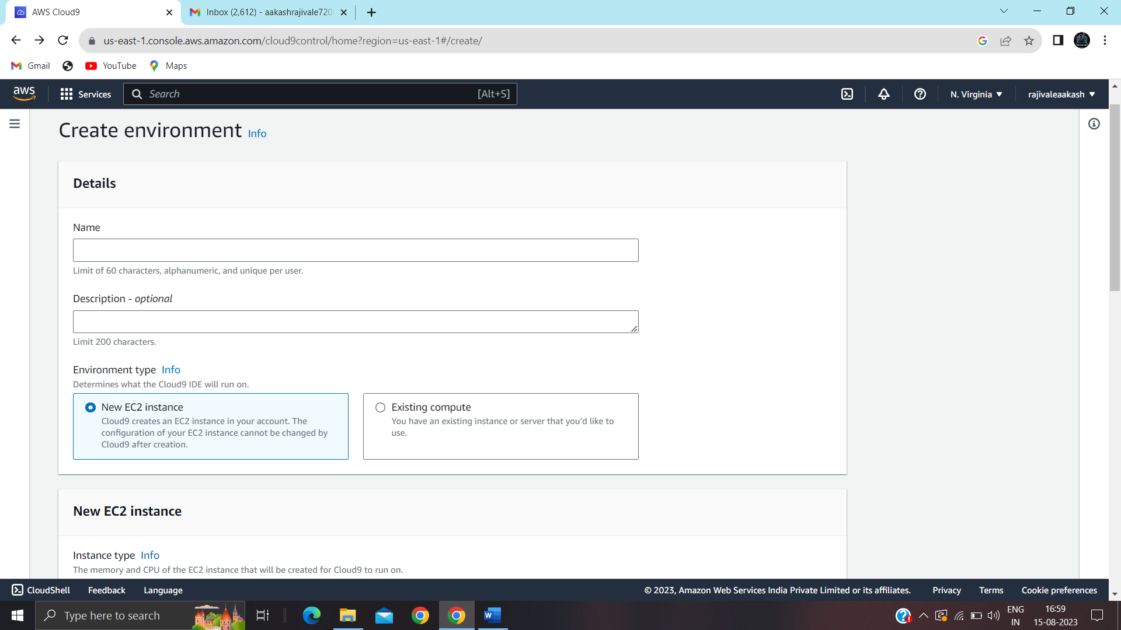

Step 7:- after the instance is created,it will be reflected here. 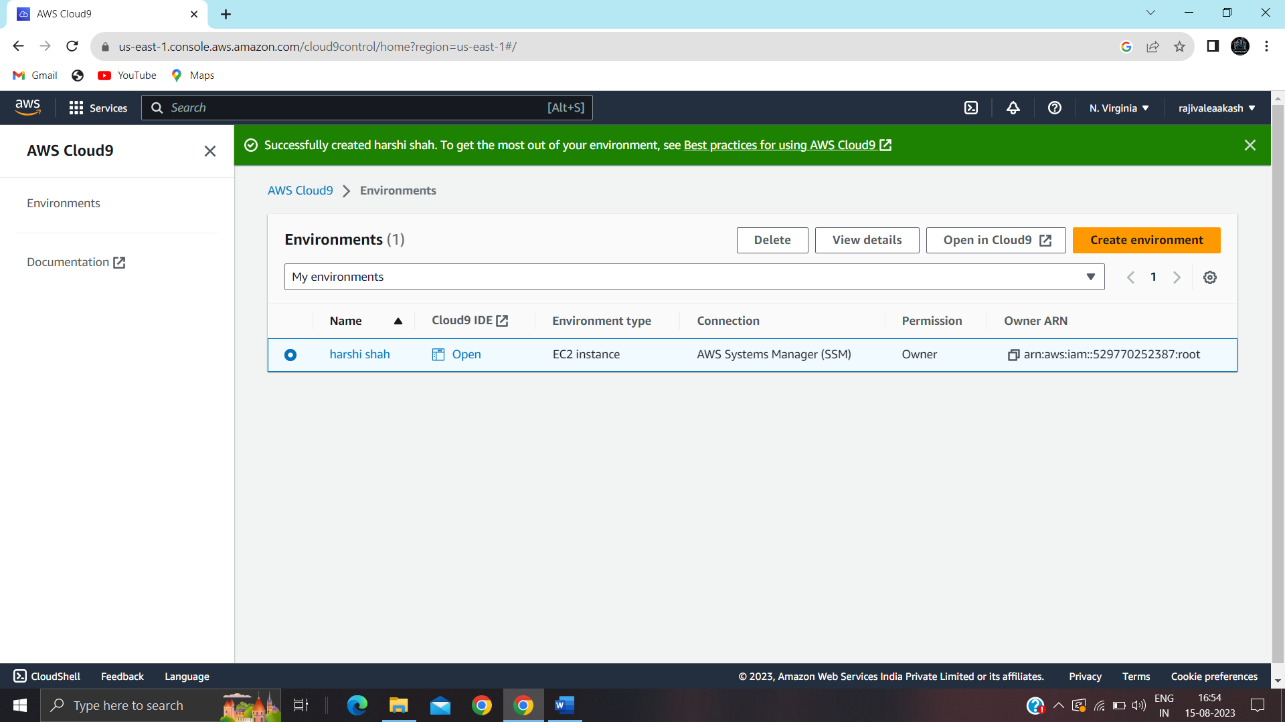

Step 8:- home page for development environment, open the IDE.

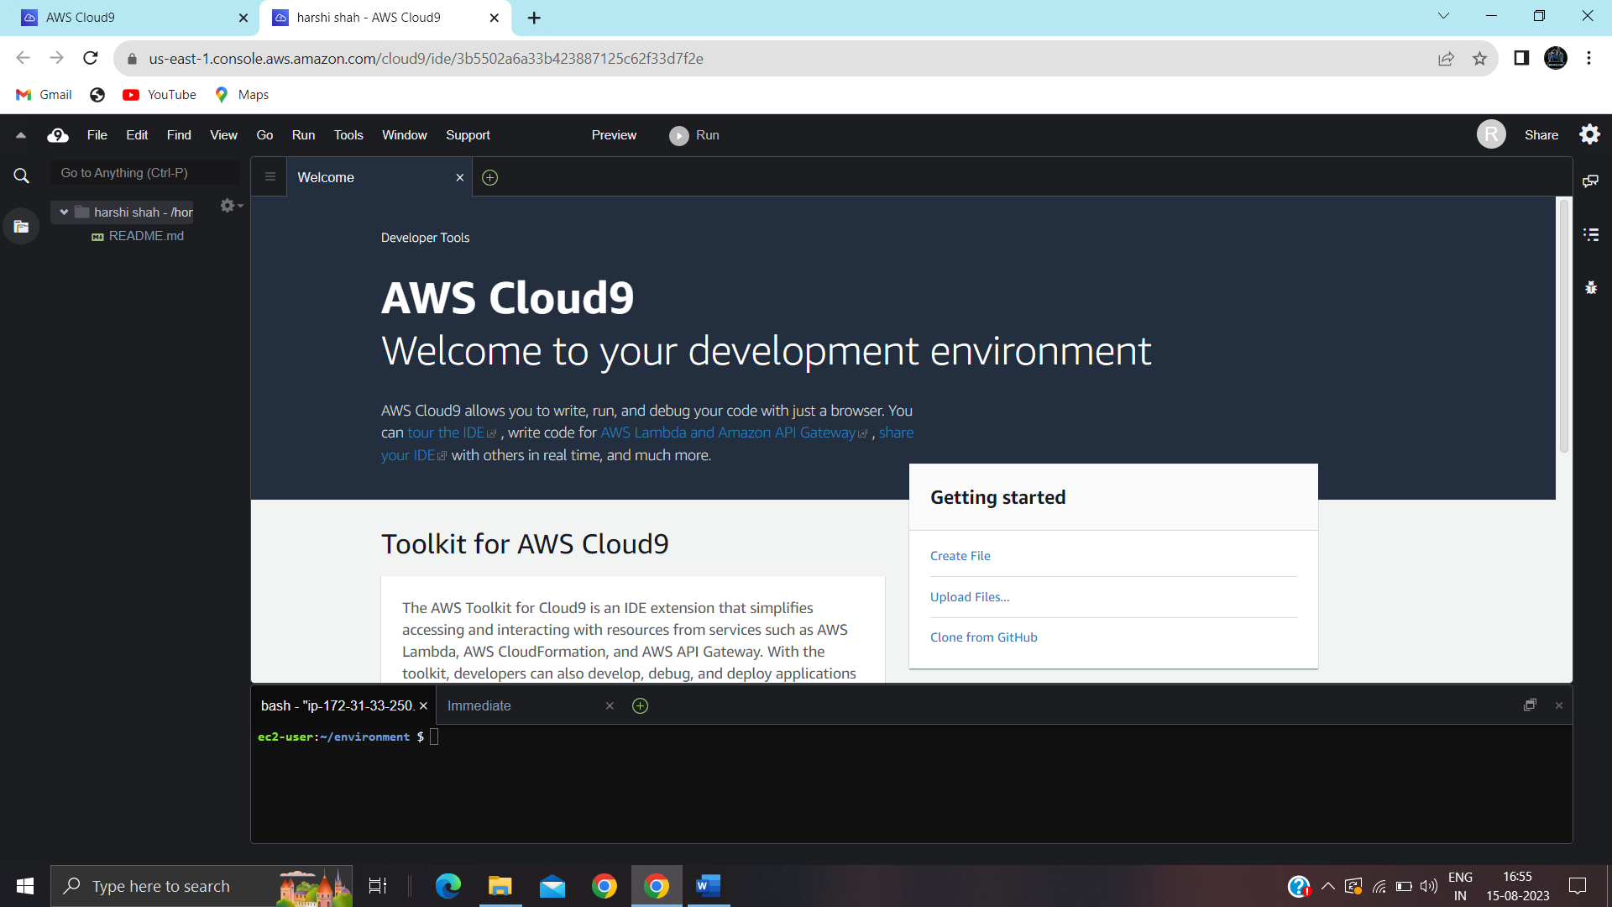

Step 9:- now create a file for programming.

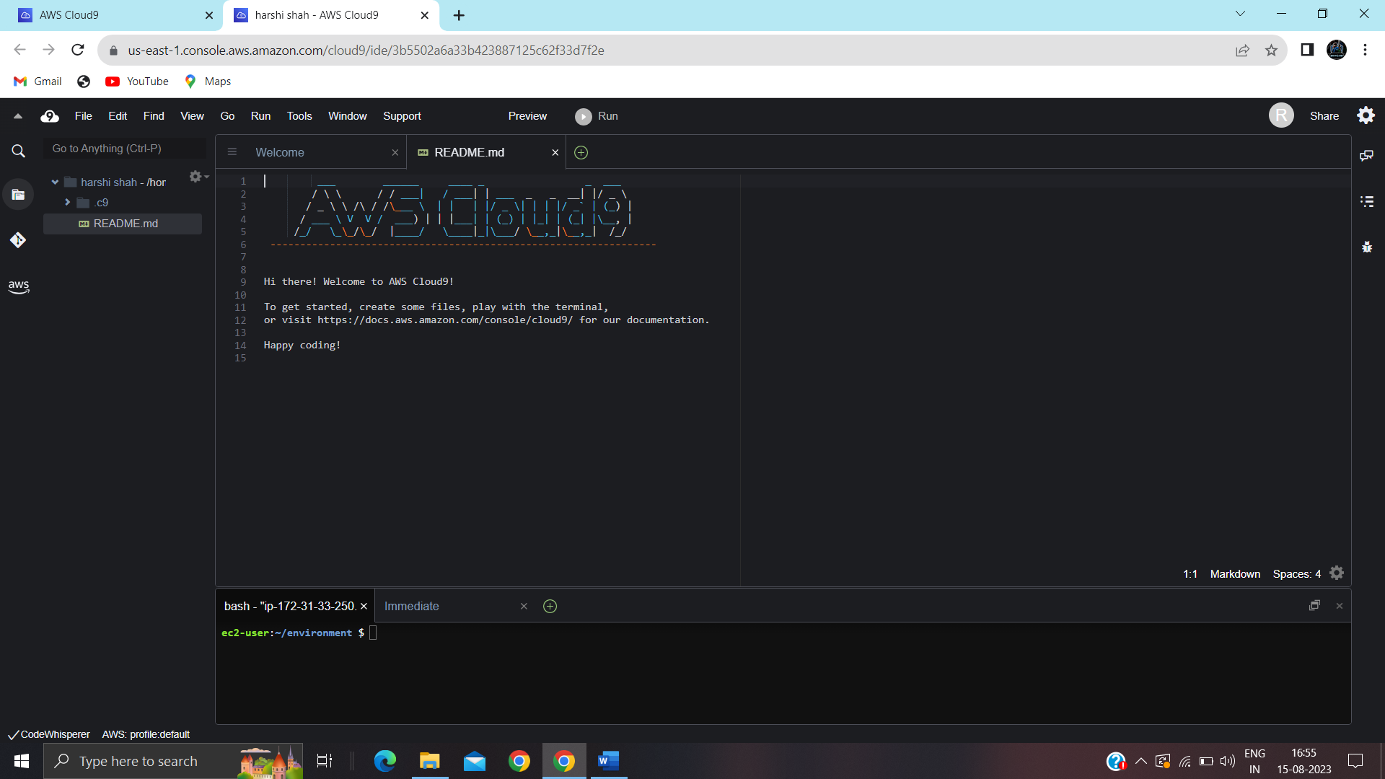

Step 10:- write a program for addition of numbers.

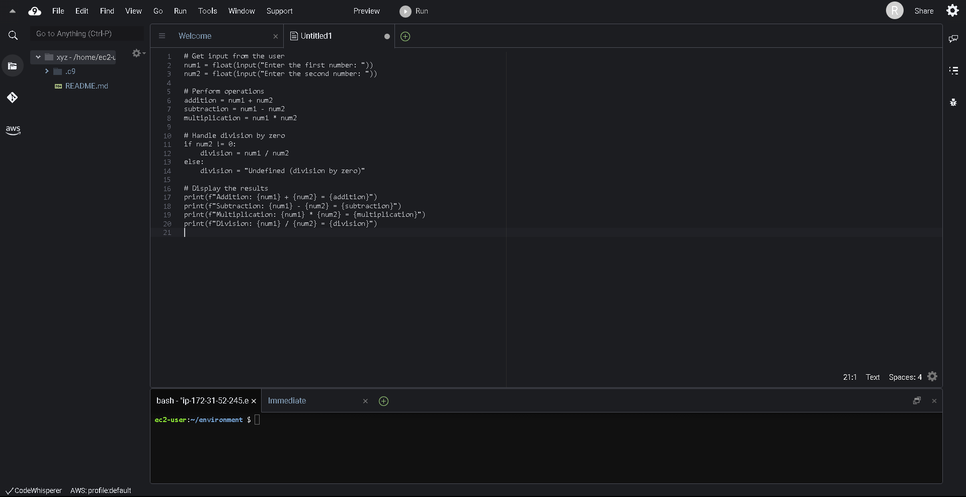

Step 11:- save the file in your created instance.

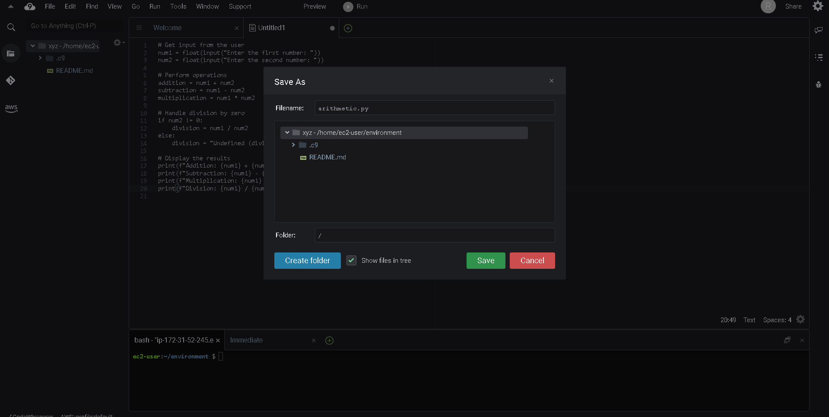

Step 12:- run the program.

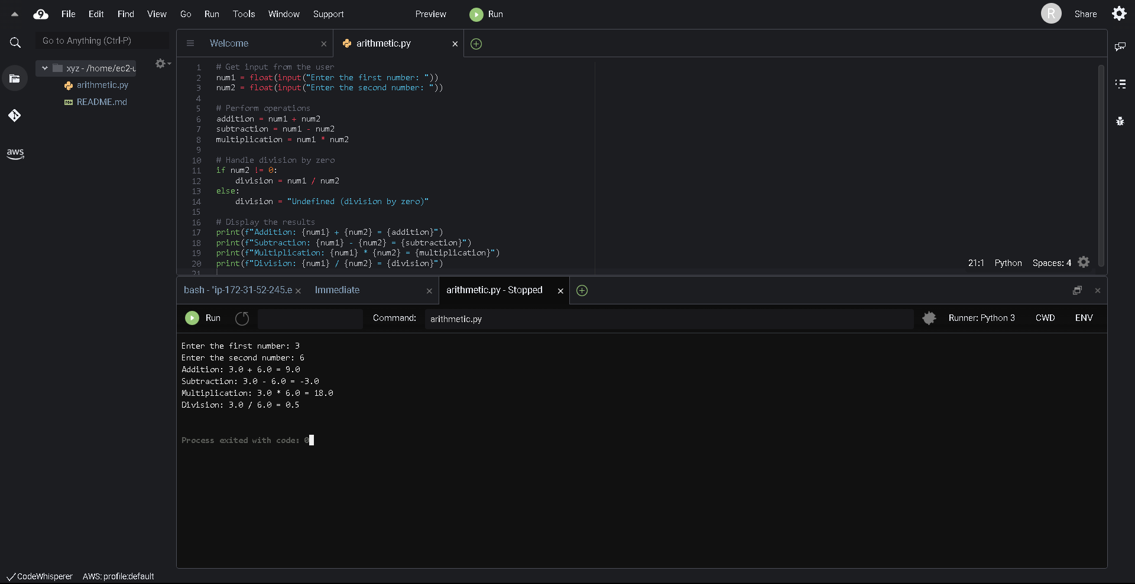

Conclusion:- In these experiment ,we have studied about the benefits and infrastructure of cloud9 and

set up the cloud IDE and run the program on the console.